Choices Level 1 – Waking Up
Plan document
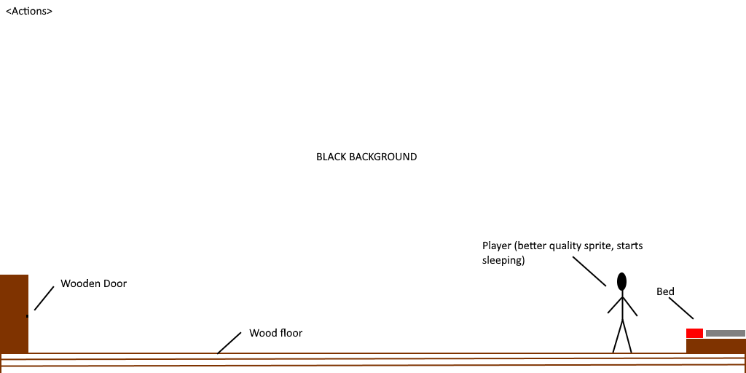
The player starts sleeping. Then wakes up after an action is performed (AID_AAA). They then walk to the door when another action is performed (AID_AAB). Then, they walk out of the door when another action is performed (AID_AAC).

Actions:
AID | Action name
AAA | WAKE UP
AAB | WALK TO DOOR
AAC | GO OUTSIDE

What actions do:
AID | Triggers...
AAA | Player gets out of bed
AAB | Player walks to door
AAC | Player walks out of door, level change

